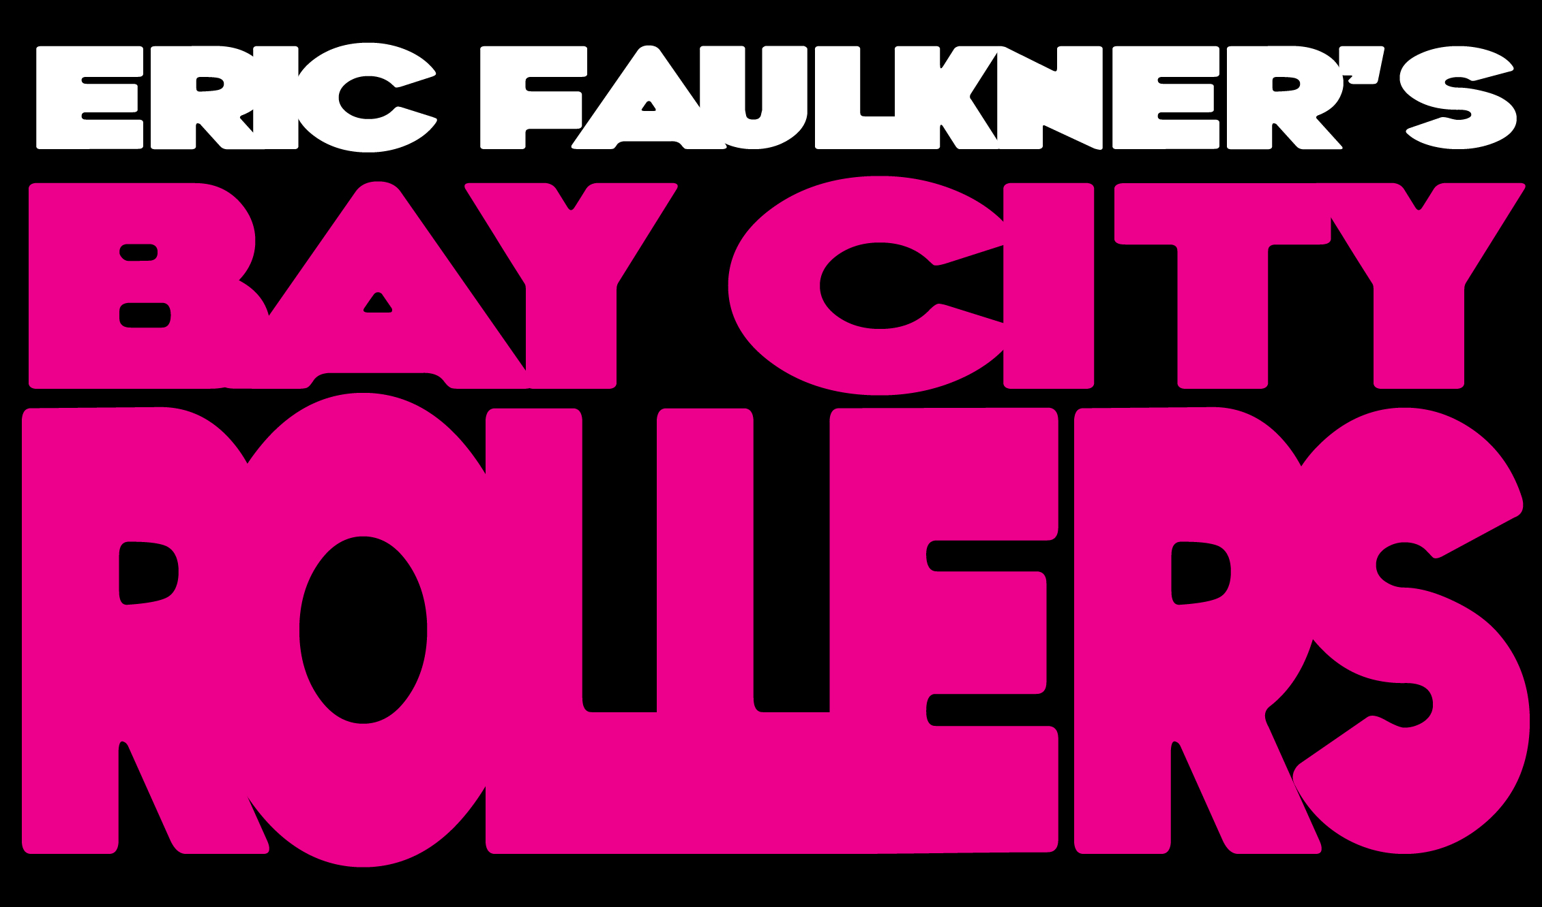

Original Bay City Roller Eric celebrates the halcyon days of Rollermania with his hard-core 70’s stomp fest. With a catalogue of over twenty world hits, three platinum and a dozen gold albums its retro blitzkrieg all the way as Eric and his band trip the Retro-sphere. With a degree in cryonics Faulkner, a true survivor of the real Greatest Rock & Roll Swindle, is in remarkably good form as he tells how it was in the good old Analogue Daze. Faulkner has amassed a stunning band; Robin Guy and David Ryder Prangly (DRP to his friends) from Rachel Stamp on drums and bass along with Phil Hendricks, front man and guitarist for The Stiffs.
The Bay City Rollers occupy a very bizarre and unique place in Rock and Pop history. They somehow managed to fill a void in the mid-seventies between Glam, Pop and Punk. You may scoff at the assessment of the latter but, at the time, they were Dee Dee Ramone’s favourite band. “The first time I went to see Dee Dee’s grave it had been raining. There were all these cool little items left on his headstone - including a 45 of the Bay City Rollers’ “Saturday Night”. Few knew Dee Dee loved them. The Ramones were asked by The BCR to record “ I wanna be your boyfriend”. Dee Dee was excited and thought he could have a hit, but the rest of the band shot him down and refused to license the song to them” (http://vague.panopia.com/articles/ramgrave/)

The Ramones have been quoted as saying that the Rollers’ classic hit “Saturday Night” was the main source of inspiration for their own “Blitzkreig Bop”. According to Johnny Ramone, the Rollers were a much bigger influence on their brand of pop-fuelled punk than anybody would have thought likely. No matter how many self-appointed arbiters of hip despised the Rollers, there were others who thought they were … well, kinda neat. Nick Lowe’s ‘Roller Show’, on his Jesus of Cool album, whether parody or pastiche, was a sign of just how big the band was at the time. “And everything will be out of sight when Eric plays his Strat tonight” (http://www.youtube.com/watch?ve=eTQKSF9Lg3Q) Christ, he even did another one, “Bay City Rollers we love you” (http://www.youtube.com/watch?v=7cgFshthNTE&feature=related)

Evidence for the Rollers’ case still survives in the grooves. A quick spin of “ Wouldn’t you like it”, “Yesterday’s Hero”, “Who’ll be my Keeper”, “Too young to Rock and Roll”, “Rock ‘n’ Roller”, “Saturday Night”, “Money Honey”, and “Rock and Roll Love Letter” makes a convincing argument for the Bay City Rollers as pop power savants. At http://www.cloudcuckoolandand.biz/music1.html you can even buy a 1970’s pair of Bay City Rollers shoes, white with red tartan design and red tartan laces, crepe soles, wording on the front reads in white ‘Bay City Rollers’, size 4, back of heels have letters BCR, made in England, designed by BARRY K.

At SPIN’S 100 Sleaziest Moments (http://www.vh1.com/news/articles/1436358/08292000/id_0.jhtml) you’ll find Faulkner at No. 24 … ‘When a member of the Bay City Rollers nearly OD’s, their manager calls the press before an ambulance’

http://www.cinemablend.com/music/Bay-City-Rollers-to-Arista-Show-Me-The-Money-3409.html gives you ‘The Bay City Rollers, a Scottish pop group who hit their stride in the 1970’s, are suing Arista Records for millions of dollars in unpaid royalties. The Rollers’ attorney, Joshua Krumholz, claims that Arista has been pocketing big chunks of change relating to the band’s hefty collection of albums, downloads, merchandising, licensing and other recordings over the past 25 years. Looks like the mega-record company may have some paying up to do. According to Playfuls.com, the suit was filed in US District Court in New York. Arista is under contractual obligations to account for and pony up royalties to the band twice a year, which, allegedly, has not been happening. “Arista has simply refused to do what its own contract requires it to do”, Krumholz says’.

The Rollers’ recorded legacy, 10 albums, is a mixed bag, offering a fair amount of record company induced drippy ballads but also a stack full of bona fide rockin’ pop. Most notable are “Money Honey”, Rock and Roll Love Letter”, “Wouldn’t you Like It”, and “Too Young to Rock and Roll”. Faulkner wrote three of these cuts and actually has 12 Roller hits to his name. Not only was the band adept at picking stellar material, they were quite capable of writing their share of catchy singles themselves, evidenced by other hits (yes, there were a few) like the glammy “Money Honey”. Dig deeper and you’ll find plenty of the sweet power pop candy plundered over the years.

For TV credits see: http://www.im.db.com/r.ame/nm0269069/filmogenre

Movieland use includes “Bye Bye Baby” in ‘Love Actually’, “Shang-a-Lang” / ‘The Filth and the Fury’, “Money Honey” / ‘The Lady Killers’, a remake of “Saturday Night” by Ned’s Atomic Dustbin featured in the Mike Myers movie ‘So I married an Ax Murderer, along with the Rollers’ original. Even a Simpsons episode is on the way …

If anything would convince you to reassess the Rollers, it would have to be how they were able to take a good tune from a little-known songwriter like Tim Moore and turn it into the fantastic rock blast of “Rock and Roll Love Letter”. In just under three minutes the Rollers destroyed their teeny-bopper image and quite successfully established themselves as a power pop force.

Links …

Eric Faulkner http://www.myspace.com/ericfaulknermusic
Robin Guy http://www.myspace.com/robinguy
David Ryder Prangley and Robin Guy http://www.myspace.com/rachelstamp
Phil Hendriks http://www.mhendriks.fsnet.co.uk/Stiffshomepage.html
http://www.myspace.com/thestiffs2000uk

Embed codes for Nick Lowe YouTube videos:
ROLLER SHOW
<object width="425" height="355"><param name="movie" value="http://www.youtube.com/v/eTQKSF9Lg3Q&hl=en"></param><param name="wmode" value="transparent"></param><embed src="http://www.youtube.com/v/eTQKSF9Lg3Q&hl=en" type="application/x-shockwave-flash" wmode="transparent" width="425" height="355"></embed></object>

WE LOVE YOU
<object width="425" height="355"><param name="movie" value="http://www.youtube.com/v/eTQKSF9Lg3Q&hl=en"></param><param name="wmode" value="transparent"></param><embed src="http://www.youtube.com/v/eTQKSF9Lg3Q&hl=en" type="application/x-shockwave-flash" wmode="transparent" width="425" height="355"></embed></object>

